Ignatov Boris 170107113

1. KB per sector =0.5;

KB per track 256;

KB per surface = 6 912 000

MB per surface = 6 750

GB per surface = 6.59

Gb per disk 65.9;

1. Ping = 7ms; download speed 30.59MBps; upload speed 33.32MBps;

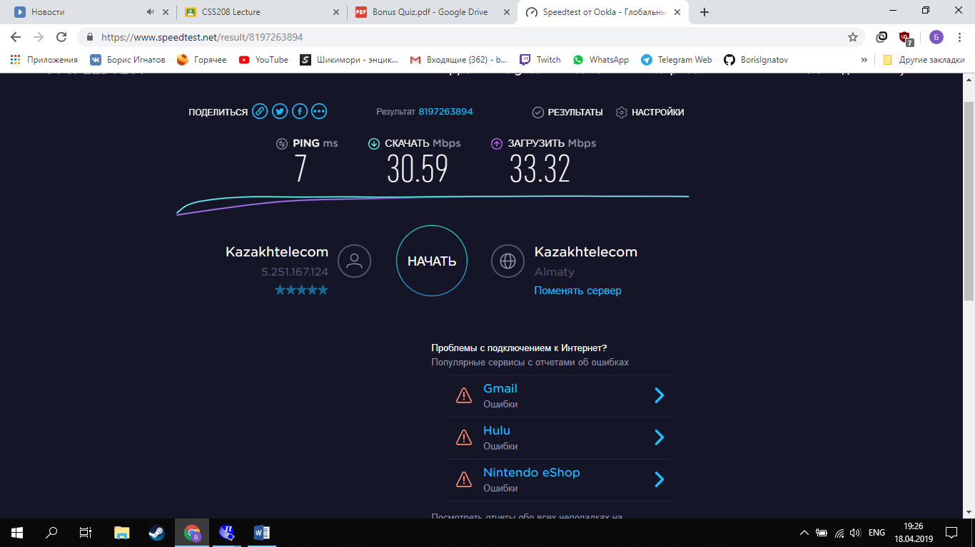

Avarage latancy = 5.55ms; bandwidth = 300Mbps; capacity = 1Tb; RPM = 5400; model - TOSHIBA MQ01ABD100

|  |  |  |  |  |
| --- | --- | --- | --- | --- |
| I/O type | Latency | Bandwidth | Upload/Write Speed | Download/Read speed |
| Network | 7ms | 31.95 | 33.32 | 30.59 |
| Disk | 5.55 | 1650 | 300 | 3000 |

3)random 1kb sector:

Transfer time = 1024/16*10^6= 0.064ms;

Rotation delay = 5.55ms;

Average latency = 12+5.55 = 17.55ms;

Time for reading 1kb random sector = 17.55+0.064 = 17.614ms;

For 3GHz 5 871 333 clock cycles;

15 625 consecutive sectors;

4) 1)30ns/133*10^-6=0.22ms;

2)1s/0.22ms = 45 454;

3) 133Mhz/45 454 = 2 925 Bps

5)66 000 000 * 4 = 264 000 000 Bps;